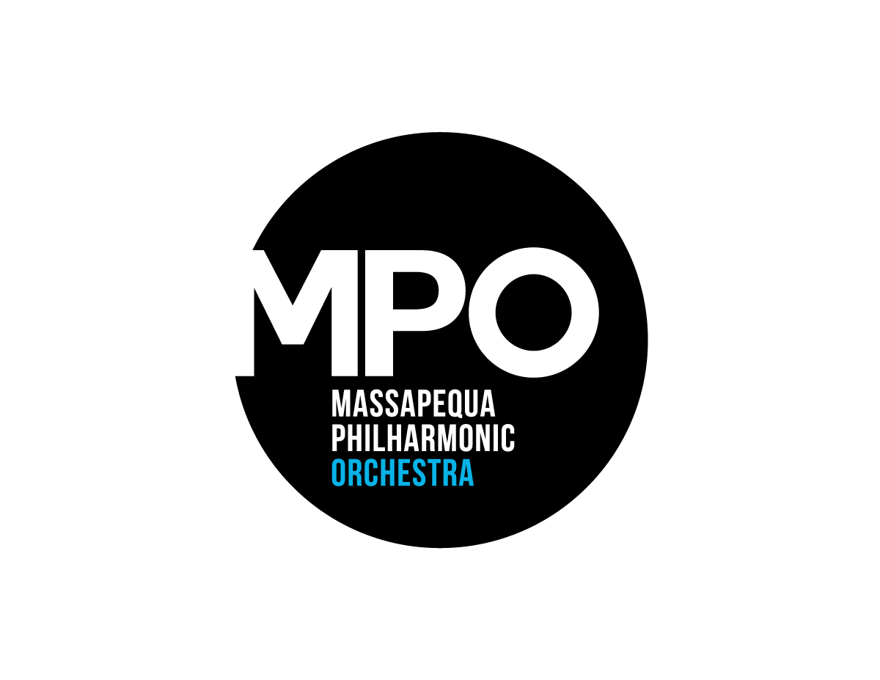
Program Book Massapequa
Advertising Philharmonic
2017/2018 Season Orchestra
Audience
The Philharmonic audience is affluent, educated and they love the performing arts. Most are between 50 and 80 and live locally. Your ad will reach 500 - 600 audience members per concert. With an ad appearing in each program for our 4 concerts a year, your ad can make up to 2400 impressions.
Sizing Prices Width Height
Full page $225 5.5" 8.5"
1/2 page vertical $125 2.75" 8.5"
1/2 page horizontal $125 5.5" 4.125"
1/4 page vertical $70 2.75" 4.125"

Ad Delivery Deadline Concert Date
October 5 October 15
December 1 December 10
March 15 March 25
April 20 May 6
To reserve space, please contact Peggy Rakas 516-551-7465
Make checks payable to: Massapequa Philharmonic Orchestra
PO Box 94
Massapequa, NY 11758-0094

